1.First of all, we need to consider that, by dividing all of pixel’s value, out histogram wont change after all; Based on that, we need to just reverse the effect of 270 degree which we applied to out original image. We assume that, this rotation was applied in clock wise.

|  |  |  |  |  |  |  |  |  |
| --- | --- | --- | --- | --- | --- | --- | --- | --- |
|  | 0 | 0 | 0 |  | 0 | 0 | 0 |  |
| 0: | 0 |  | 0 | Reverse rotation: | 0 |  | 0 | :0 |
|  | 0 | 0 | 0 |  | 0 | 0 | 0 |  |

|  |  |  |  |  |  |  |  |  |
| --- | --- | --- | --- | --- | --- | --- | --- | --- |
|  | 0 | 1 | 0 |  | 0 | 0 | 0 |  |
| 34: | 0 |  | 0 | Reverse rotation: | 1 |  | 1 | :136 |
|  | 0 | 1 | 0 |  | 0 | 0 | 0 |  |

|  |  |  |  |  |  |  |  |  |
| --- | --- | --- | --- | --- | --- | --- | --- | --- |
|  | 1 | 1 | 1 |  | 0 | 1 | 1 |  |
| 143: | 1 |  | 1 | Reverse rotation: | 0 |  | 1 | :62 |
|  | 0 | 0 | 0 |  | 0 | 1 | 1 |  |

|  |  |  |  |  |  |  |  |  |
| --- | --- | --- | --- | --- | --- | --- | --- | --- |
|  | 1 | 1 | 1 |  | 1 | 1 | 1 |  |
| 247: | 1 |  | 0 | Reverse rotation: | 1 |  | 1 | :223 |
|  | 1 | 1 | 1 |  | 1 | 0 | 1 |  |

Our original histogram was something like this:

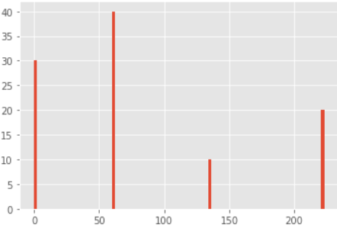

For calculating uniform histogram independent of rotation, we consider 10 different codes which 9 of them are for uniform histogram independent of rotation (0-8) and one of them is for all of non-uniform (9).

Code 0: is for all histogram without any one on it.

Code 1: is for all of histogram with just only have one.

…

Code 9: is for all of non-uniform histogram.

So, for our original image, our uniform histogram independent of rotation will be like this:

(Code, value) = {(0, 30), (1, 0), (2, 0), (3, 0), (4, 0), (5, 40), (6, 0), (7, 20), (8, 0), (9, 10)}

For our initial image, our uniform histogram independent of rotation will be like this:

(Code, value) = {(0, 30), (1, 0), (2, 0), (3, 0), (4, 0), (5, 40), (6, 0), (7, 20), (8, 0), (9, 10)}

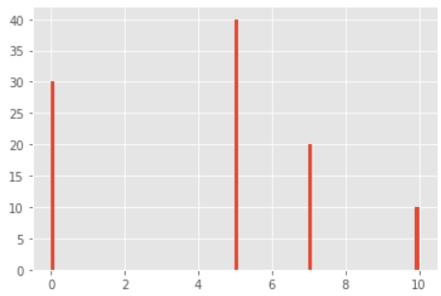

So, we can see that, both of them are same. This is because of removing dependency of rotation in our histogram and based on that, we can demonstrate that, applying rotation to our original image, wont effect on the “uniform histogram independent of rotation” which we calculate it on upper part.